**Introduction**



Math statistics 5120 Project



Gerard shu Fuhnwi and **Godlove Jator**



Course instructor: Dr. Mathew Jones

The Ford Motor Company is an American multinational automaker headquartered in Dearborn, Michigan, a suburb of Detroit. It was founded by Henry Ford and incorporated on June 1903. The Company sells automobiles and commercial vehicles under the Ford brand (model) and most luxury cars under the Lincoln brand (model). Ford also has branches in Brazil, United Kingdom and Australia. We seek to build a model to predict the prices of used Ford Cars in certain locations in the United State of American.

**Data description**

|  |  |
| --- | --- |
| **Variable Name** | **Description** |
| **Color** | Color of the Car |
| **Year** | The year in which the car was produced |
| **Mileage** | Number of miles a car covers |
| **Location** | Place where a car is in the United states |
| **Price** | Price of used car in $ |
| **Model** | Brand of the used car |
| **Age** | Age of car |

# NB: This data was collected from 1990 to 2009

**Data Link:** <https://assets.datacamp.com/production/course_1586/datasets/Fords.csv>



**Structure of the data**

setwd("C:/Users/Gerard/Desktop/Gboy") Ford_cars= read.csv("fords.csv") names(Ford_cars)

[1] "X" "Year" "Mileage" "Price" "Color" "Location" "Model"

"Age" str(Ford_cars)

'data.frame': 635 obs. of 8 variables:

$ X : int 1 2 3 4 5 6 7 8 9 10 ...

$ Year : int 1990 1994 1995 1995 1995 1996 1997 1998 1998 1999 ...

$ Mileage : int NA 94000 NA 68000 NA 115730 74564 143000 91000 88000 ...

$ Price : int 1600 1988 2288 2495 1995 2199 2995 1200 2488 3300 ...

$ Color : Factor w/ 10 levels "beige","black",..: NA 10 10 NA NA 1 8 3 9 1

0 ...

$ Location: Factor w/ 6 levels "Cambridge","Dallas",..: 5 5 5 5 5 5 5 3 5 5

...

$ Model : Factor w/ 6 levels "GL","Limited",..: NA 1 NA NA 1 1 1 4 NA NA .

..

$ Age : int 19 15 14 14 14 13 12 11 11 10 ...

summary(Ford_cars)

X Year Mileage Price Color

Min. : 1.0 Min. :1990 Min. : 42 Min. : 1200 gray :191

1st Qu.:159.5 1st Qu.:2003 1st Qu.: 31773 1st Qu.: 5995 white :101

Median :318.0 Median :2006 Median : 48898 Median : 8950 beige : 63

Mean :318.0 Mean :2005 Mean : 56016 Mean : 9421 blue : 59

3rd Qu.:476.5 3rd Qu.:2007 3rd Qu.: 74503 3rd Qu.:11665 black : 55

Max. :635.0 Max. :2009 Max. :181484 Max. :21995 (Other):156

NA's :19 NA's :6 NA's : 10

Location Model Age

Cambridge :141 GL : 16 Min. : 0.00

Dallas :136 Limited: 32 1st Qu.: 2.00

Fresno : 23 LX : 12 Median : 3.00

Philadelphia:137 SE :283 Mean : 4.28

Phoenix : 85 SEL :208 3rd Qu.: 6.00

St Paul :113 SES : 76 Max. :19.00

NA's : 8

head(Ford_cars,10)

X Year Mileage Price Color Location Model Age

1. 1 1990 NA 1600 <NA> Phoenix <NA> 19
2. 2 1994 94000 1988 white Phoenix GL 15
3. 3 1995 NA 2288 white Phoenix <NA> 14
4. 4 1995 68000 2495 <NA> Phoenix <NA> 14
5. 5 1995 NA 1995 <NA> Phoenix GL 14
6. 6 1996 115730 2199 beige Phoenix GL 13
7. 7 1997 74564 2995 green Phoenix GL 12
8. 8 1998 143000 1200 blue Fresno SE 11
9. 9 1998 91000 2488 red Phoenix <NA> 11
10. 10 1999 88000 3300 white Phoenix <NA> 10



**Data Cleaning**

The dataset had some missing values for some variables like mileage(predictor) and price (response), so we had to replace them with the median since it is not affected by extreme values.

# Code

Ford_cars1=Ford_cars

Ford_cars1$Mileage[which(is.na(Ford_cars$Mileage))]=median(Ford_cars1$Mileage,na.rm = T) Ford_cars1

Ford_cars2=Ford_cars1

Ford_cars2$Price[which(is.na(Ford_cars1$Price))]=median(Ford_cars2$Price,na.rm = T) head(Ford_cars2[-1], 10)

# Output

head(Ford_cars2[-1],10)

Year Mileage Price Color Location Model Age

1. 1990 48897.5 1600 <NA> Phoenix <NA> 19
2. 1994 94000.0 1988 white Phoenix GL 15
3. 1995 48897.5 2288 white Phoenix <NA> 14
4. 1995 68000.0 2495 <NA> Phoenix <NA> 14
5. 1995 48897.5 1995 <NA> Phoenix GL 14
6. 1996 115730.0 2199 beige Phoenix GL 13
7. 1997 74564.0 2995 green Phoenix GL 12
8. 1998 143000.0 1200 blue Fresno SE 11
9. 1998 91000.0 2488 red Phoenix <NA> 11
10. 1999 88000.0 3300 white Phoenix <NA> 10

**Checking for correlation of variables**



# Code

cor(Ford_cars2[,-c(5:7)])

pairs(~ Price + Mileage + Color + Age + Location + Year + Model , data = Ford_cars2, main = "Ford Used Cars Data") **Output**

cor(Ford_cars2[,-c(5:7)])

X Year Mileage Price Age

X 1.00000000 -0.05635155 0.1496194 -0.03270205 0.05635155

Year -0.05635155 1.00000000 -0.7339419 0.78525840 -1.00000000

Mileage 0.14961940 -0.73394194 1.0000000 -0.78021127 0.73394194

Price -0.03270205 0.78525840 -0.7802113 1.00000000 -0.78525840 Age 0.05635155 -1.00000000 0.7339419 -0.78525840 1.00000000

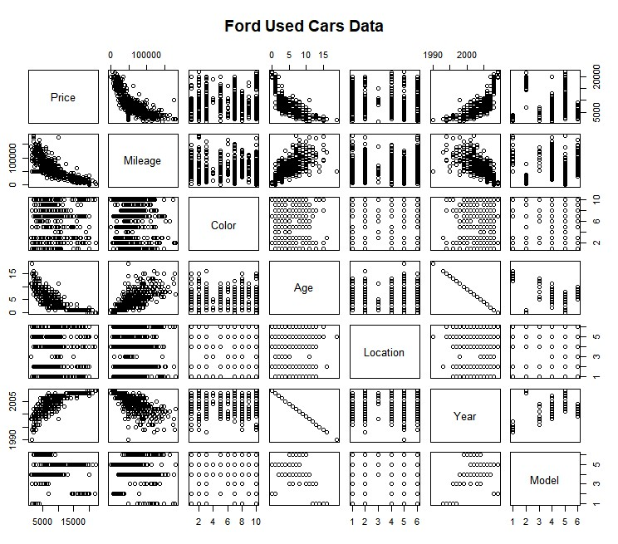

**Observation:** From the output above, we can observe that the response variable (Price) is highly correlated with the predictor variables (Year, Age and mileage).

**NB:** Since Year is highly correlated with age, we will remove year and used age in our model.



**Regression model**

**Model 1 Code**

fit1=lm(Price~., data = Ford_cars2) summary(fit1)

plot(fit1) confint(fit1)

**Output**

summary(fit1) Call: lm(formula = Price ~ ., data = Ford_cars2)

Residuals:

Min 1Q Median 3Q Max

-6255.2 -1253.5 -31.7 1231.0 10372.6

Coefficients: (1 not defined because of singularities)

Estimate Std. Error t value Pr(>|t|)

(Intercept) -1.179e+06 9.525e+04 -12.384 < 2e-16 ***

X -8.549e+00 1.866e+00 -4.582 5.61e-06 ***

Year 5.955e+02 4.758e+01 12.513 < 2e-16 ***

Mileage -4.620e-02 3.822e-03 -12.088 < 2e-16 ***

Colorblack 1.355e+03 3.668e+02 3.693 0.000242 ***

Colorblue 1.375e+03 3.636e+02 3.781 0.000172 ***

Colorbrown 2.261e+03 9.154e+02 2.470 0.013789 *

Colorburgundy 8.772e+02 3.784e+02 2.318 0.020779 * Colorgold 8.812e+02 5.139e+02 1.715 0.086930 .

Colorgray 1.257e+03 2.980e+02 4.217 2.86e-05 ***

Colorgreen 6.331e+02 3.862e+02 1.639 0.101676

Colorred 9.963e+02 4.585e+02 2.173 0.030165 *

Colorwhite 2.047e+03 3.642e+02 5.621 2.92e-08 ***

LocationDallas 2.769e+03 6.568e+02 4.215 2.88e-05 ***

LocationFresno -2.209e+03 5.134e+02 -4.302 1.98e-05 ***

LocationPhiladelphia 1.469e+03 3.435e+02 4.277 2.21e-05 ***

LocationPhoenix -2.217e+03 3.761e+02 -5.894 6.30e-09 ***

LocationSt Paul 2.832e+03 6.431e+02 4.404 1.26e-05 ***

ModelLimited 2.487e+03 7.755e+02 3.207 0.001414 **

ModelLX -1.582e+03 7.787e+02 -2.031 0.042686 *

ModelSE -3.017e+03 6.284e+02 -4.801 1.99e-06 ***

ModelSEL -4.267e+02 6.754e+02 -0.632 0.527846

ModelSES -2.438e+03 6.192e+02 -3.938 9.19e-05 ***

Age NA NA NA NA ---

Signif. codes: 0 ‘***’ 0.001 ‘**’ 0.01 ‘*’ 0.05 ‘.’ 0.1 ‘ ’ 1

Residual standard error: 1954 on 597 degrees of freedom

(15 observations deleted due to missingness)

Multiple R-squared: 0.8302, Adjusted R-squared: 0.8239

F-statistic: 132.7 on 22 and 597 DF, p-value: < 2.2e-16

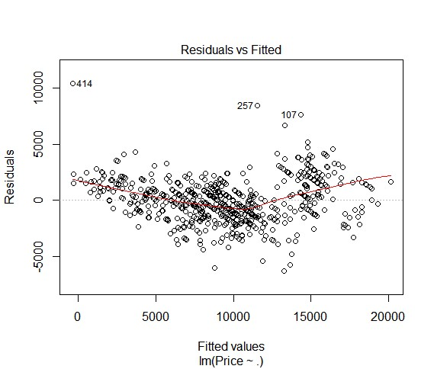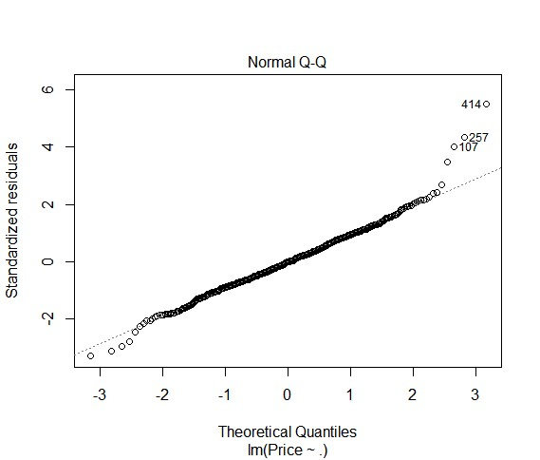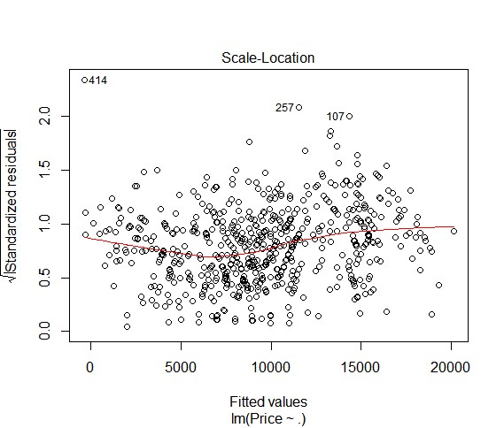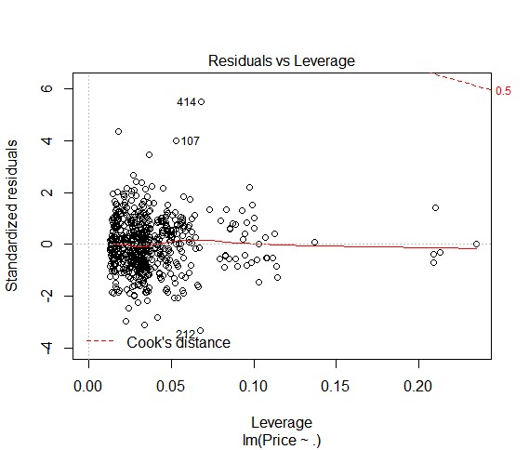

**Observation:** Most of the variable in the model above seem significant, but may be overfitted due to so many variables, and equally the predictor variable (age) seem to disappear in our model, which has a lot to do with the response variable (Price). So, we will fit another base mostly on the quantitative predictor variables (age and mileage). It can also be observed from the plots above that 257, 414 and 107 seem to be outliers.

This can also be confirmed by the outlierTest below:

outlierTest(fit1)

rstudent unadjusted p-value Bonferonni p 414 5.639082 2.6421e-08 1.6381e-05

257 4.417334 1.1869e-05 7.3590e-03

107 4.065437 5.4375e-05 3.3713e-02



**Training and Testing**

# • Training Code

n=nrow(Ford_cars2)

trainindex = sample(1:n, size = round(0.7*n), replace = F) train_Ford = Ford_cars2[trainindex,] test_Ford = Ford_cars2[-trainindex,] head(train_Ford) head(test_Ford)

# Output

head(train_Ford)

X Year Mileage Price Color Location Model Age

19 19 2002 48897.5 2788 gray Phoenix SEL 7

418 418 2004 79650.0 4950 black Dallas SE 5

423 423 2000 64600.0 5995 black St Paul SE 9

478 478 2006 65956.0 8999 gold Dallas SEL 3

322 322 2005 43675.0 7991 white Philadelphia SE 4

555 555 2008 35508.0 13995 green St Paul SEL 1

> head(test_Ford)

X Year Mileage Price Color Location Model Age

5 5 1995 48897.5 1995 <NA> Phoenix GL 14

9 9 1998 91000.0 2488 red Phoenix <NA> 11

1. 13 2000 115123.0 2995 white Phoenix SE 9
2. 14 2000 99000.0 2988 gray Phoenix SES 9

17 17 2002 48897.5 2800 blue Phoenix SE 7

24 24 2003 80267.0 6491 white Phoenix SES 6



**Simple Linear Model**

# Code

fit2=lm(Price~Age, data = train_Ford) plot(Price~Age, data = train_Ford) abline(fit2, lwd=2, col="red") summary(fit2)

plot(fit2) outlierTest(fit2) confint(fit2)

# Output

fit2=lm(Price~Age, data = train_Ford)

> summary(fit2) Call: lm(formula = Price ~ Age, data = train_Ford)

Residuals:

Min 1Q Median 3Q Max

-6019.0 -1950.8 -557.1 1670.4 8623.5

Coefficients:

Estimate Std. Error t value Pr(>|t|)

(Intercept) 14127.22 221.85 63.68 <2e-16 ***

Age -1113.20 41.28 -26.97 <2e-16 ***

---

Signif. codes: 0 ‘***’ 0.001 ‘**’ 0.01 ‘*’ 0.05 ‘.’ 0.1 ‘ ’ 1

Residual standard error: 2838 on 442 degrees of freedom

Multiple R-squared: 0.622, Adjusted R-squared: 0.6211

F-statistic: 727.2 on 1 and 442 DF, p-value: < 2.2e-16

outlierTest(fit2)

No Studentized residuals with Bonferonni p < 0.05

Largest |rstudent|:

rstudent unadjusted p-value Bonferonni p 1 3.145378 0.0017709 0.7863

> confint(fit2)

2.5 % 97.5 % (Intercept) 13691.215 14563.23

Age -1194.327 -1032.07

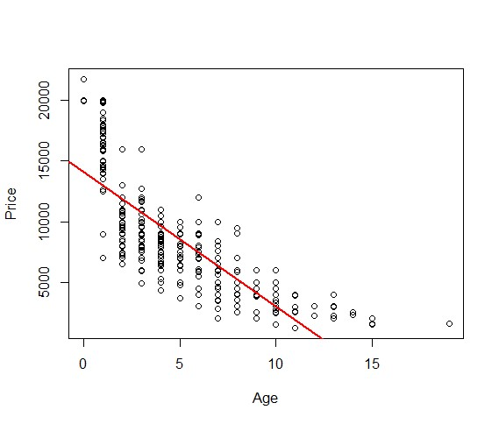

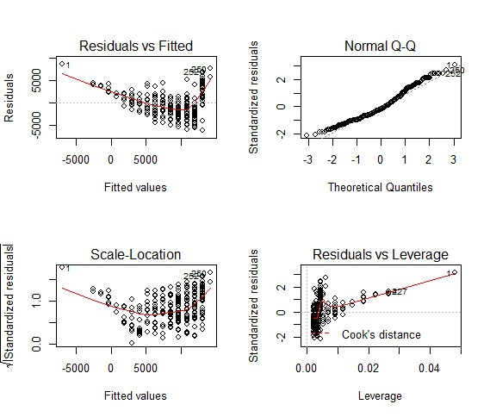



**Multiple Regression**

fit3=lm(Price~Age + Mileage, data = train_Ford)

> summary(fit3) Call: lm(formula = Price ~ Age + Mileage, data = train_Ford)

Residuals:

Min 1Q Median 3Q Max

-6231 -1662 -205 1555 7525

Coefficients:

Estimate Std. Error t value Pr(>|t|)

(Intercept) 1.570e+04 2.282e+02 68.80 <2e-16 ***

Age -6.637e+02 5.042e+01 -13.16 <2e-16 ***

Mileage -6.315e-02 5.034e-03 -12.54 <2e-16 ***

---

Signif. codes: 0 ‘***’ 0.001 ‘**’ 0.01 ‘*’ 0.05 ‘.’ 0.1 ‘ ’ 1

Residual standard error: 2439 on 441 degrees of freedom

Multiple R-squared: 0.7214, Adjusted R-squared: 0.7201

F-statistic: 571 on 2 and 441 DF, p-value: < 2.2e-16

> par(mfrow=c(2,2))

> plot(fit)

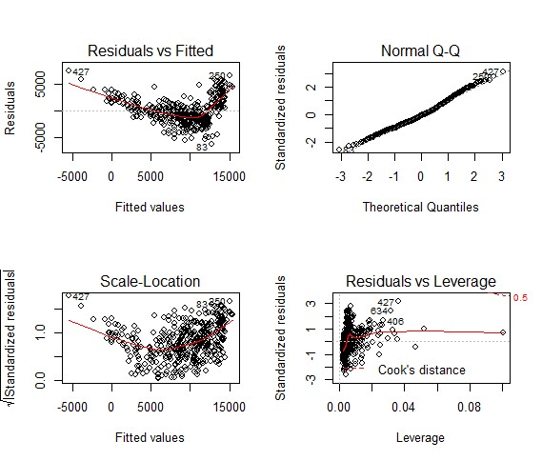

confint(fit3)

2.5 % 97.5 % (Intercept) 1.525171e+04 1.614871e+04

Age -7.628441e+02 -5.646556e+02

Mileage -7.304136e-02 -5.325528e-02

> vif(fit3)

Age Mileage

2.019758 2.019758

> outlierTest(fit3)

No Studentized residuals with Bonferonni p < 0.05

Largest |rstudent|: rstudent unadjusted p-value Bonferonni p 427 3.173831 0.0016099 0.71482

ncvTest(fit3)

Non-constant Variance Score Test

Variance formula: ~ fitted.values

Chisquare = 15.8425 Df = 1 p = 6.883869e-05

# Interactions

fit4 =lm(Price~Age*Mileage, data = train_Ford)

> summary(fit4) Call: lm(formula = Price ~ Age * Mileage, data = train_Ford)

Residuals:

Min 1Q Median 3Q Max

-6801.9 -1276.1 79.4 1216.0 5639.3

Coefficients:

Estimate Std. Error t value Pr(>|t|)

(Intercept) 1.893e+04 2.783e+02 68.03 <2e-16 ***

Age -1.456e+03 6.537e+01 -22.28 <2e-16 ***

Mileage -1.288e-01 5.870e-03 -21.95 <2e-16 ***

Age:Mileage 1.213e-02 7.838e-04 15.47 <2e-16 ***

---

Signif. codes: 0 ‘***’ 0.001 ‘**’ 0.01 ‘*’ 0.05 ‘.’ 0.1 ‘ ’ 1

Residual standard error: 1965 on 440 degrees of freedom

Multiple R-squared: 0.8196, Adjusted R-squared: 0.8184

F-statistic: 666.3 on 3 and 440 DF, p-value: < 2.2e-16

vif(fit4)

Age Mileage Age:Mileage

5.230901 4.231971 10.211028 > ncvTest(fit4)

Non-constant Variance Score Test

Variance formula: ~ fitted.values

Chisquare = 19.64682 Df = 1 p = 9.3158e-06 outlierTest(fit4)

No Studentized residuals with Bonferonni p < 0.05

Largest |rstudent|: rstudent unadjusted p-value Bonferonni p 83 -3.513209 0.00048865 0.21696

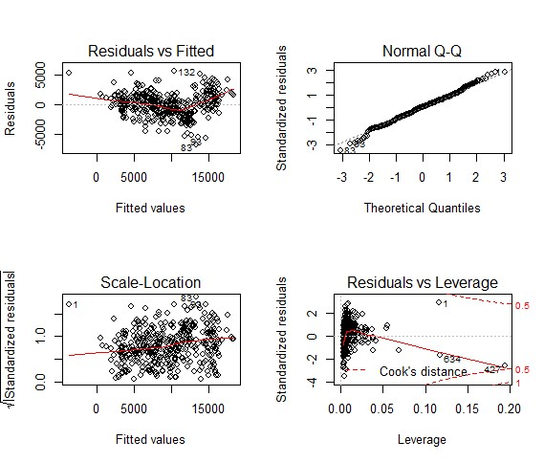

# Nonlinear terms

summary(fit5) Call: lm(formula = Price ~ Mileage + I(Mileage^2), data = train_Ford)

Residuals:

Min 1Q Median 3Q Max

-7612 -1398 151 1523 8555

Coefficients:

Estimate Std. Error t value Pr(>|t|)

(Intercept) 1.953e+04 3.597e+02 54.28 <2e-16 ***

Mileage -2.629e-01 1.121e-02 -23.46 <2e-16 ***

I(Mileage^2) 1.064e-06 7.426e-08 14.32 <2e-16 ***

---

Signif. codes: 0 ‘***’ 0.001 ‘**’ 0.01 ‘*’ 0.05 ‘.’ 0.1 ‘ ’ 1

Residual standard error: 2379 on 441 degrees of freedom

Multiple R-squared: 0.7351, Adjusted R-squared: 0.7339

F-statistic: 612 on 2 and 441 DF, p-value: < 2.2e-16

outlierTest(fit5)

No Studentized residuals with Bonferonni p < 0.05

Largest |rstudent|: rstudent unadjusted p-value Bonferonni p 132 3.653701 0.00028966 0.12861

vif(fit5)

Mileage I(Mileage^2)

10.53042 10.53042

> ncvTest(fit5)

Non-constant Variance Score Test

Variance formula: ~ fitted.values

Chisquare = 3.974273 Df = 1 p = 0.0462004

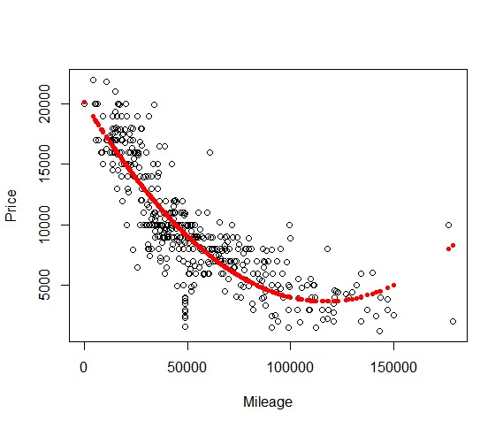

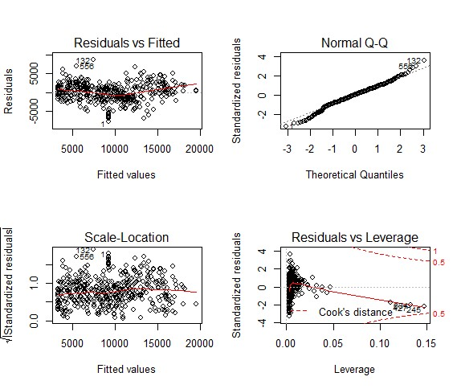

fit6=lm(Price~poly(Mileage,4), data = train_Ford)

> summary(fit6) Call: lm(formula = Price ~ poly(Mileage, 4), data = train_Ford)

Residuals:

Min 1Q Median 3Q Max

-6964.7 -1256.1 10.3 1431.5 8764.0

Coefficients:

Estimate Std. Error t value Pr(>|t|) (Intercept) 9373.6 105.3 89.05 < 2e-16 *** poly(Mileage, 4)1 -75919.2 2218.1 -34.23 < 2e-16 *** poly(Mileage, 4)2 34066.3 2218.1 15.36 < 2e-16 *** poly(Mileage, 4)3 -17234.5 2218.1 -7.77 5.61e-14 *** poly(Mileage, 4)4 6166.2 2218.1 2.78 0.00567 **

---

Signif. codes: 0 ‘***’ 0.001 ‘**’ 0.01 ‘*’ 0.05 ‘.’ 0.1 ‘ ’ 1

Residual standard error: 2218 on 439 degrees of freedom

Multiple R-squared: 0.7707, Adjusted R-squared: 0.7686

F-statistic: 368.9 on 4 and 439 DF, p-value: < 2.2e-16 ncvTest(fit6)

Non-constant Variance Score Test

Variance formula: ~ fitted.values

Chisquare = 5.764245 Df = 1 p = 0.01635551

> outlierTest(fit6)

rstudent unadjusted p-value Bonferonni p 132 4.028644 6.6134e-05 0.029363

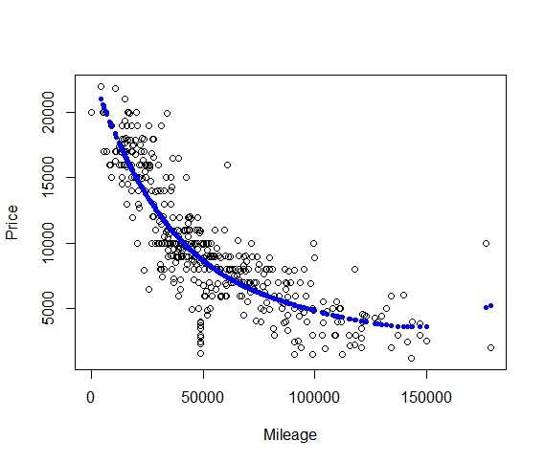

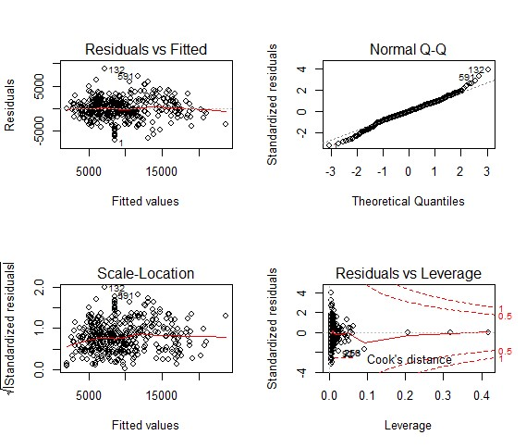



**Final Model**

fit7=lm(Price~Mileage + Age + I(Age^2) + I(Mileage^4), data = train_Ford[-c(4

27,83,132,590)])

> summary(fit7) Call: lm(formula = Price ~ Mileage + Age + I(Age^2) + I(Mileage^4), data = train_Ford[-c(427, 83, 132, 590)])

Residuals:

Min 1Q Median 3Q Max

-6617.5 -1478.5 111.5 1393.9 5635.5

Coefficients:

Estimate Std. Error t value Pr(>|t|)

(Intercept) 1.785e+04 2.571e+02 69.436 < 2e-16 ***

Mileage -7.840e-02 6.823e-03 -11.491 < 2e-16 ***

Age -1.470e+03 1.238e+02 -11.876 < 2e-16 ***

I(Age^2) 5.982e+01 7.945e+00 7.530 2.91e-13 ***

I(Mileage^4) 9.854e-18 1.494e-18 6.596 1.22e-10 ***

---

Signif. codes: 0 ‘***’ 0.001 ‘**’ 0.01 ‘*’ 0.05 ‘.’ 0.1 ‘ ’ 1

Residual standard error: 2084 on 439 degrees of freedom

Multiple R-squared: 0.7975, Adjusted R-squared: 0.7957

F-statistic: 432.3 on 4 and 439 DF, p-value: < 2.2e-16

vif(fit7)

Mileage Age I(Age^2) I(Mileage^4)

5.082076 16.683139 12.356260 2.826909

> outlierTest(fit7)

No Studentized residuals with Bonferonni p < 0.05

Largest |rstudent|:

rstudent unadjusted p-value Bonferonni p 1 -3.566284 0.00040198 0.17848

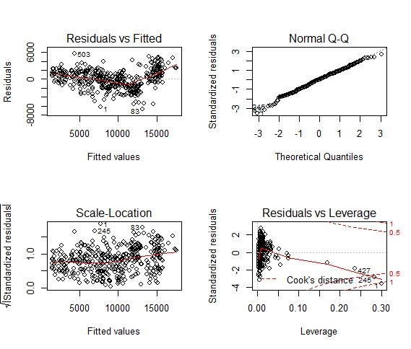



**Testing the Model**

fit9=lm(Price~Mileage + Age + I(Age^2) + I(Mileage^4), data = test_Ford)

> summary(fit9) Call: lm(formula = Price ~ Mileage + Age + I(Age^2) + I(Mileage^4), data = test_Ford)

Residuals:

Min 1Q Median 3Q Max

-5784.2 -1176.5 -139.2 1341.9 7349.1

Coefficients:

Estimate Std. Error t value Pr(>|t|)

(Intercept) 1.856e+04 3.891e+02 47.704 < 2e-16 ***

Mileage -9.444e-02 1.136e-02 -8.315 1.89e-14 ***

Age -1.537e+03 2.123e+02 -7.241 1.14e-11 ***

I(Age^2) 7.302e+01 1.390e+01 5.251 4.10e-07 ***

I(Mileage^4) 1.559e-17 2.285e-18 6.822 1.23e-10 ***

---

Signif. codes: 0 ‘***’ 0.001 ‘**’ 0.01 ‘*’ 0.05 ‘.’ 0.1 ‘ ’ 1

Residual standard error: 2130 on 186 degrees of freedom

Multiple R-squared: 0.8117, Adjusted R-squared: 0.8077

F-statistic: 200.5 on 4 and 186 DF, p-value: < 2.2e-16

ncvTest(fit9)

Non-constant Variance Score Test

Variance formula: ~ fitted.values

Chisquare = 1.58147 Df = 1 p = 0.208549

> vif(fit9)

Mileage Age I(Age^2) I(Mileage^4)

6.915764 20.957953 14.464315 3.365227

> plot(fit9)

> outlierTest(fit9)

No Studentized residuals with Bonferonni p < 0.05

Largest |rstudent|:

rstudent unadjusted p-value Bonferonni p 257 3.571813 0.00045197 0.086327

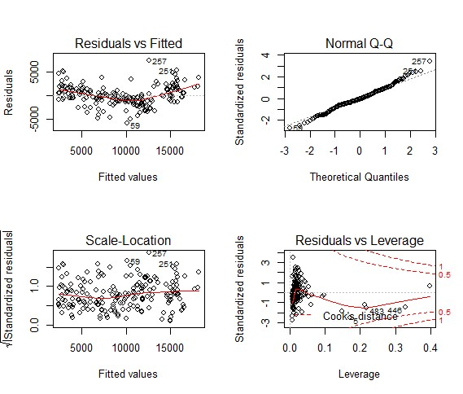



**Residual Analysis**

Residual analysis is usually done graphically or using basic library in R.

## • Outlier

> outlierTest(fit9)

No Studentized residuals with Bonferonni p < 0.05

Largest |rstudent|: rstudent unadjusted p-value Bonferonni p

257 3.571813 0.00045197 0.086327

From the outlier test, it shows that 257 is an outlier, so we can decide to remove it to improve on our model.

## • Influential observations

This can be checked using added variable plots in R using the car package. avPlots(fit9, id.n =2, id.cex=0.7)

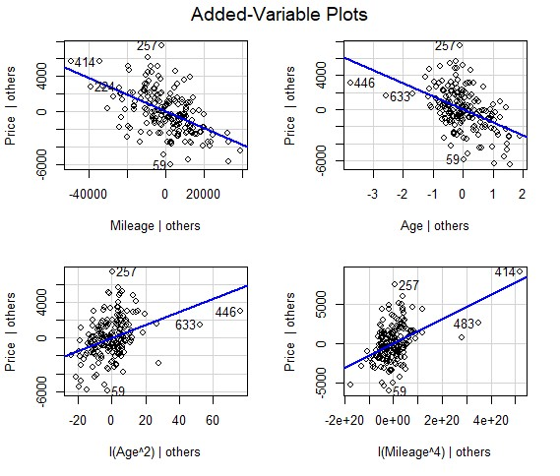

## • Non-Normality

hist(residuals(fit9)) shapiro.test(residuals(fit9))

boxplot(residuals(fit9), horizontal = T) sreid=studres(fit9)

hist(sresid, freq=FALSE, main="Distribution of Studentized Residuals") shapiro.test(residuals(fit9))

Shapiro-Wilk normality test

data: residuals(fit9) W = 0.98979, p-value = 0.1913

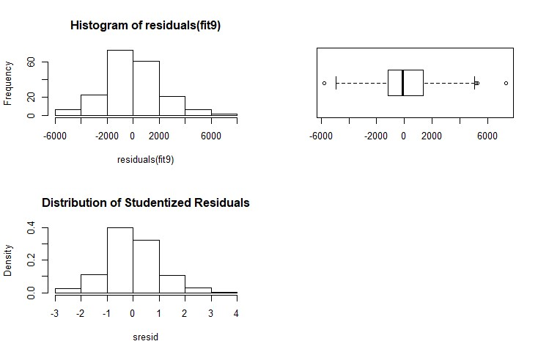

## • Non-Constant Error Variance

This can be done with the car library in R or graphically.

ncvTest(fit9)

Non-constant Variance Score Test

Variance formula: ~ fitted.values Chisquare = 1.58147 Df = 1 p = 0.208549

spreadLevelPlot(fit9)

Suggested power transformation: 0.8355619

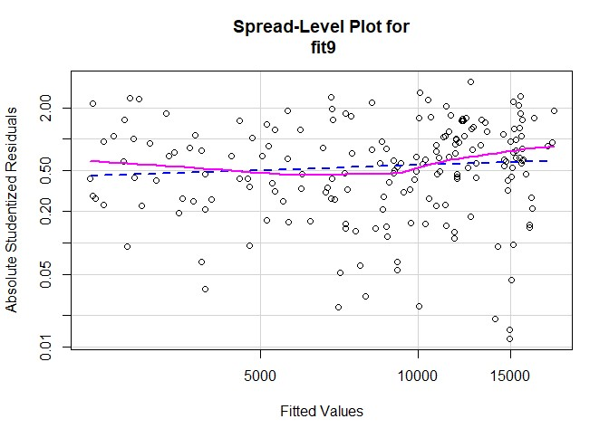

## • Multi-Collinearity

vif(fit9)

Mileage Age I(Age^2) I(Mileage^4)

6.915764 20.957953 14.464315 3.365227 sqrt(vif(fit9))

Mileage Age I(Age^2) I(Mileage^4)

2.629784 4.577986 3.803198 1.834455

## • Non-Linearity

This can be determine using **crPlots** and **ceresplots** in R using the car package.

> crPlots(fit9)

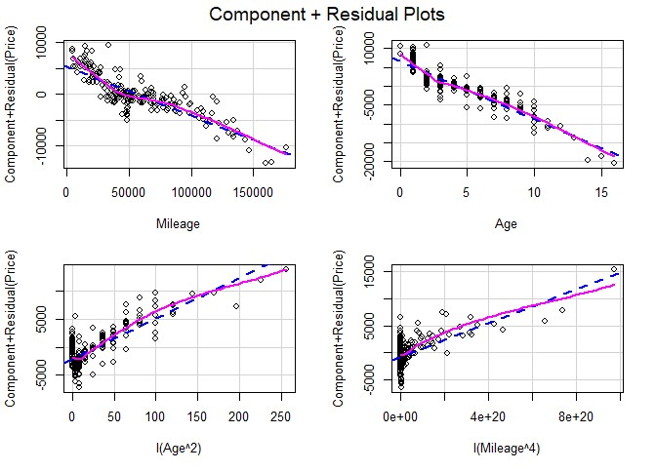

## • Non-Independence of Errors

durbinWatsonTest(fit9)

lag Autocorrelation D-W Statistic p-value 1 0.225358 1.515181 0 Alternative hypothesis: rho != 0

## • Analysis of Variance

* anova(fit9)
* Analysis of Variance Table

•

* Response: Price

Df Sum Sq Mean Sq F value Pr(>F)

Mileage 1 2715016257 2715016257 598.364 < 2.2e-16 ***

Age 1 329821215 329821215 72.689 5.162e-15 ***

I(Age^2) 1 382938764 382938764 84.396 < 2.2e-16 ***

I(Mileage^4) 1 211138433 211138433 46.533 1.227e-10 ***

Residuals 186 843956112 4537398 ---



Hence the best model for predicting the Price for used Ford cars in the United State is a polynomial Model of degree.